Unit 1 test answer key

Multiple Choice
1C
2B
3A
4B
5C
6D
7A
8A
9B
10D

True/False
1T
2F
3T
4T
5F
6T
7F

Matching
1D
2G
3E
4A
5F
6C
7B
8H

Short Answer
- An atom can achieve a stable octet by sharing, losing, or gaining electrons.
- 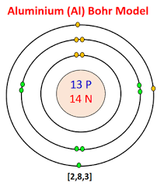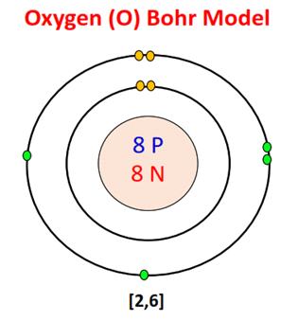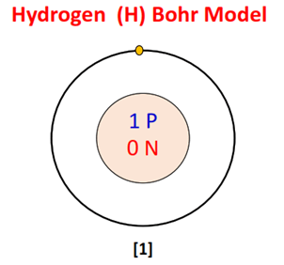
- 
- An aluminum atom has an atomic number of 13 and a mass number of 27.
- Ionizationenergy is the energy change that occurs when an atom gains electron and when atom loses an electron
- Sodium, potassium, chloride, calcium, magnesium, and. phosphate are examples of electrolytes. An electrolyte is a substance that produces an electrically conducting solution when dissolved in a polar solvent, such as water.
- Chemical formula writing for an ionic compound always has a net zero charge, meaning the total positive charge must equal the total negative charge.
- Sulfate, nitrate, bromate
- The three major types of intermolecular interactions are dipole–dipole interactions, London dispersion forces (these two are often referred to collectively as van der Waals forces), and hydrogen bonds.
- IV is most likely an ionic compound because because its high solution conductivity indicates that ions are present in the solution.
- 3,4,6,8
- Standardized naming system for chemical compounds ensures that a spoken or written chemical name leaves no doubts concerning which chemical compound the name refers to and each chemical name should refer to a single substance.

Long Answer
- a) Ionization energy increases from left to right on the periodic table.
b) The lower this energy is, the more readily the atom becomes a cation. Therefore, the higher this energy is, the more unlikely it is the atom becomes a cation. Generally, elements on the right side of the periodic table have a higher ionization energy because their valence shell is nearly filled. Elements on the left side of the periodic table have low ionization energies because of their willingness to lose electrons and become cations.
c)From top to bottom down a group, electronegativity decreases.
d)This is because atomic number increases down a group, and thus there is an increased distance between the valence electrons and nucleus, or a greater atomic radius.

- 0.1264 * 302.04 = 38.177856
0.1823 * 304.12 = 55.441076
0.6913 * 305.03 = 210.867239
38.177856 + 55.441076 + 210.867239 = 304.49
The average atomic mass of element X is 304.49
- 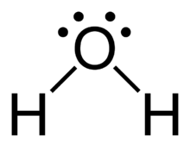Water has an electronegativity value of 1.5. The molecule is polar.

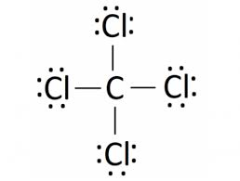The electronegativity difference is 0.61. The molecule is nonpolar.

- London dispersion forces occur between nonpolar molecules and are extremely weak. Dipole-dipole forces are between polar molecules, and since polar molecules have slight charges, their force is more similar to ions, giving them a moderately strong bond. Substances with dipole-dipole attractions tend to have higher melting and boiling points compared to nonpolar molecules

